**Initial setup: logon to VM as rustam5**

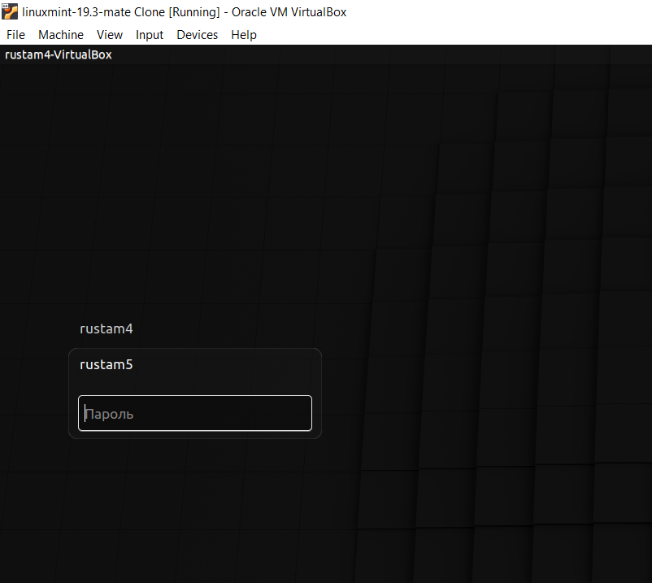

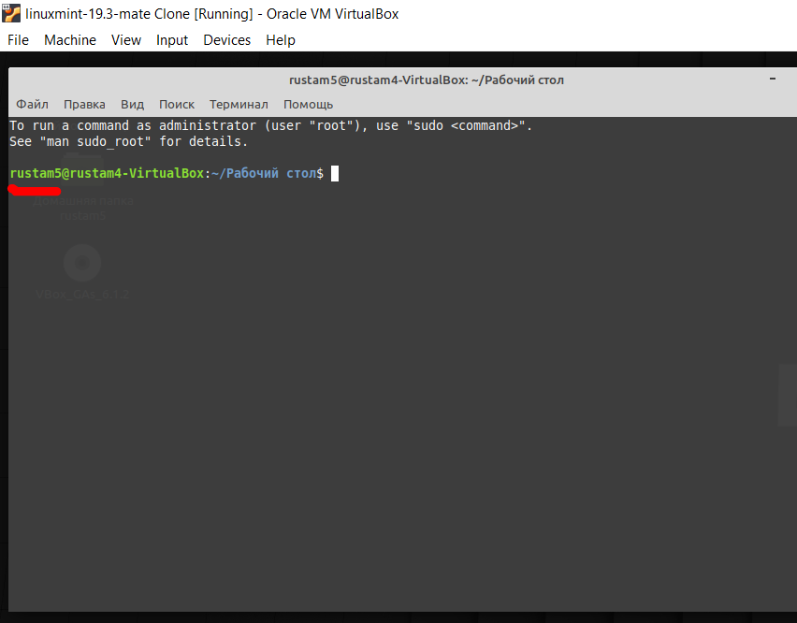

Press “e” during restart VM:

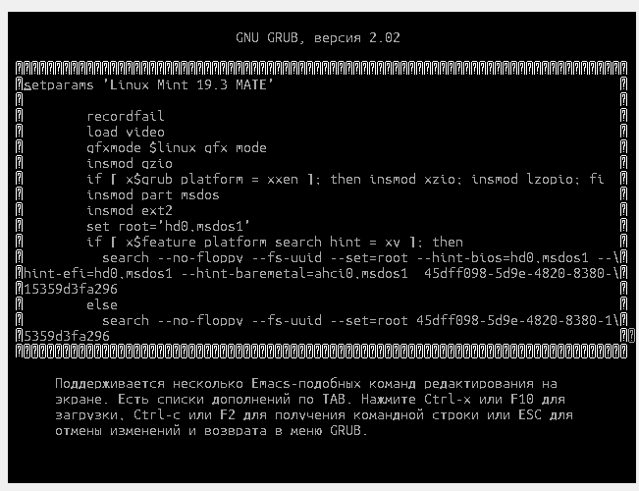

**Need to find line that with linux or linux16 in the beginning.**

from

<https://wiki.ubuntu.com/Kernel/KernelBootParameters>

Note: The parameter(s) you've added to the linux line are only temporary: They will affect this boot session, but once you restart the system they will no longer be in effect.

**Option 1**

Change password with option **init=/bin/sh**

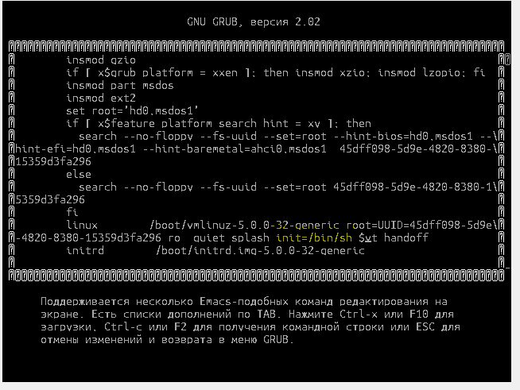

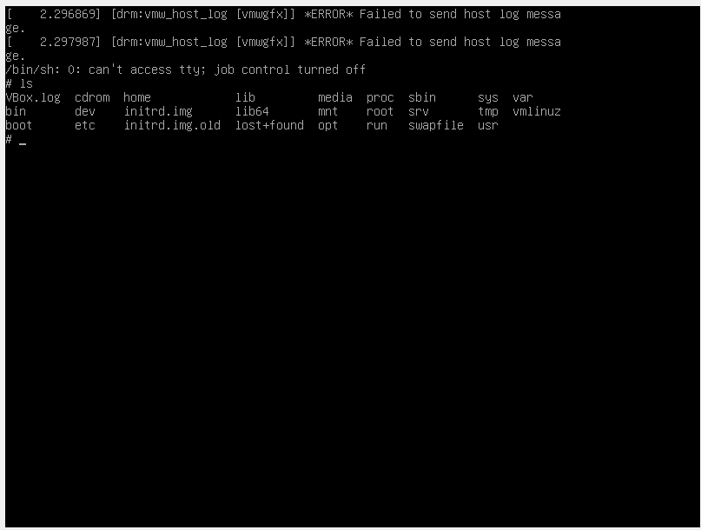

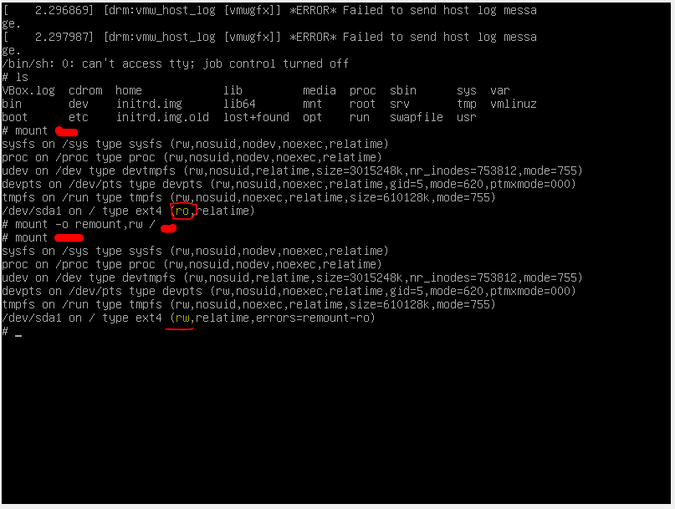

**Change passwd**

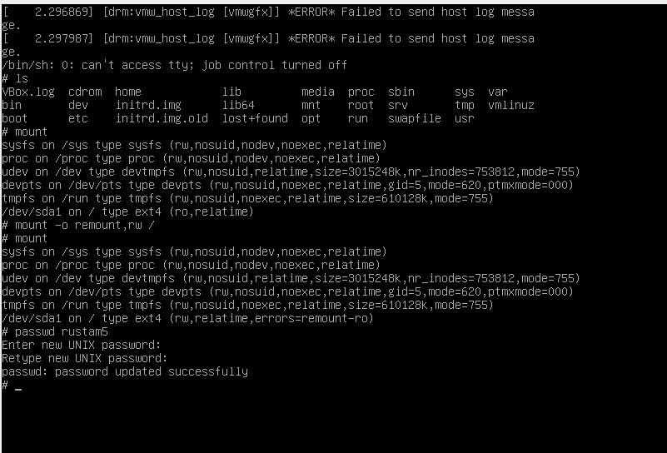

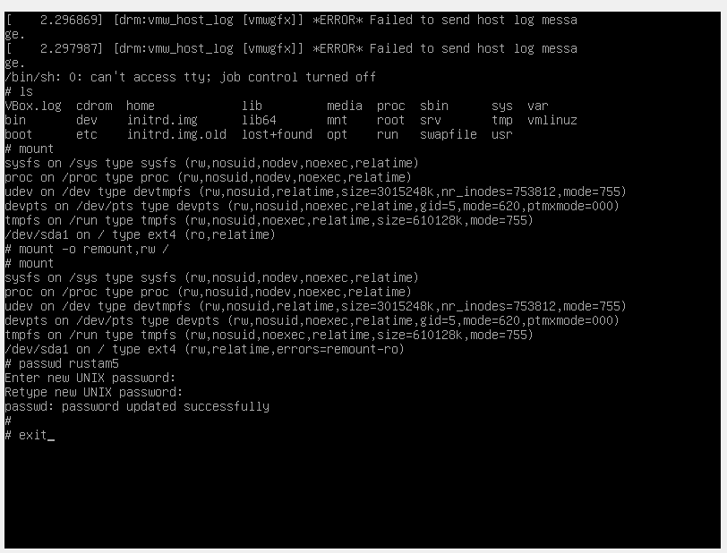

**Logon to system with updated passwd:**

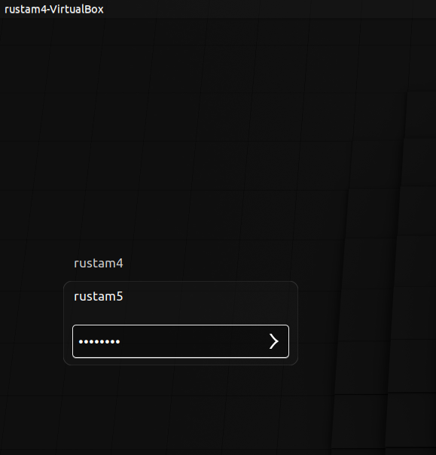

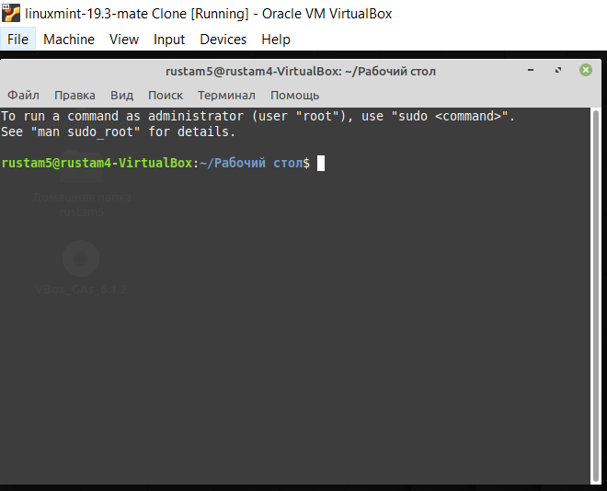

**Option 2**

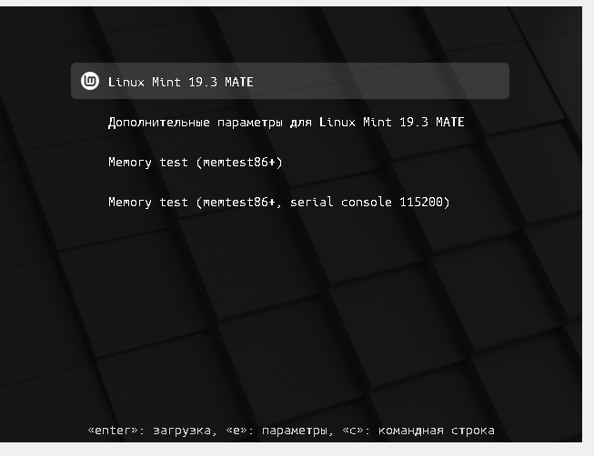

**Adding rd.break**

rd.break was added couple times:

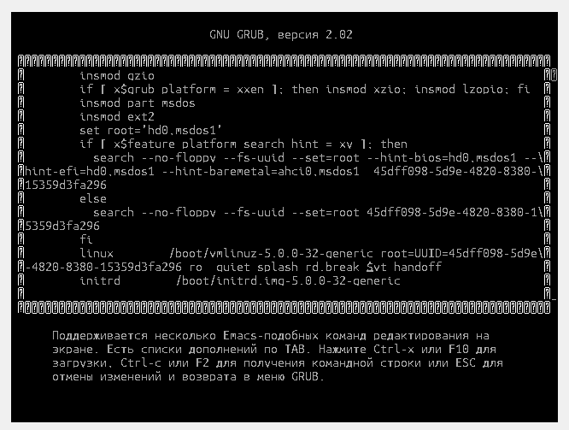

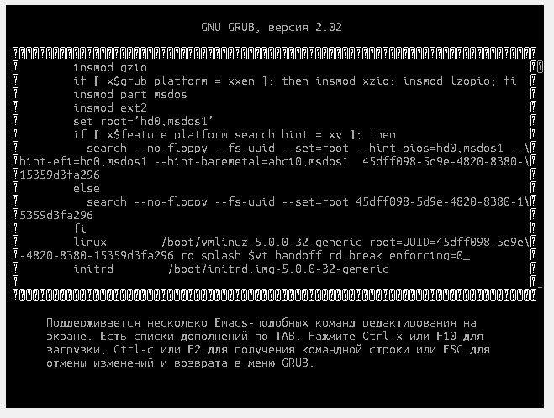

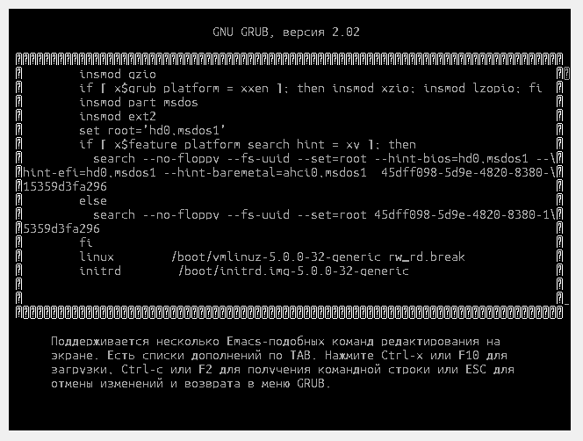

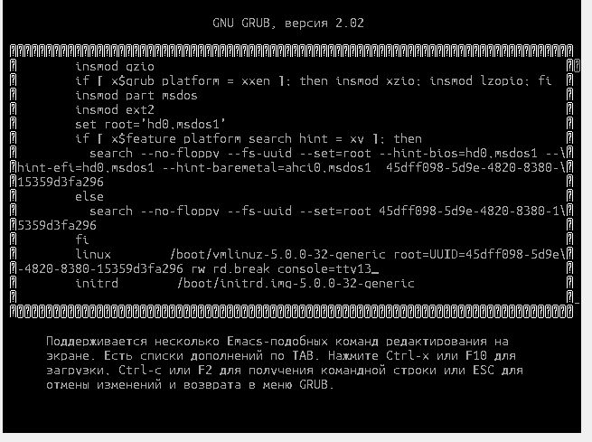

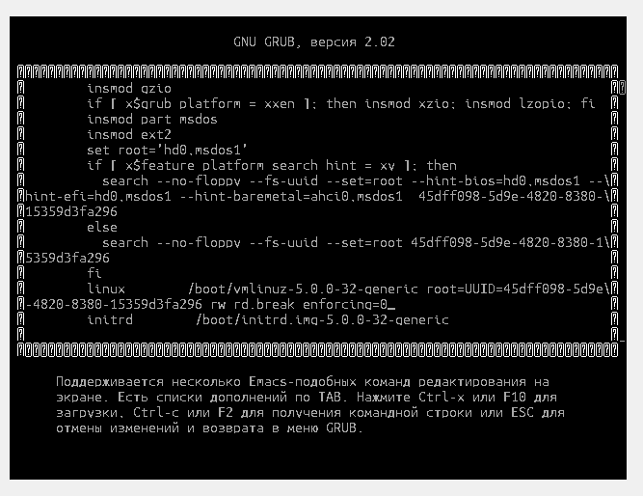

But system loaded in normal way every time:

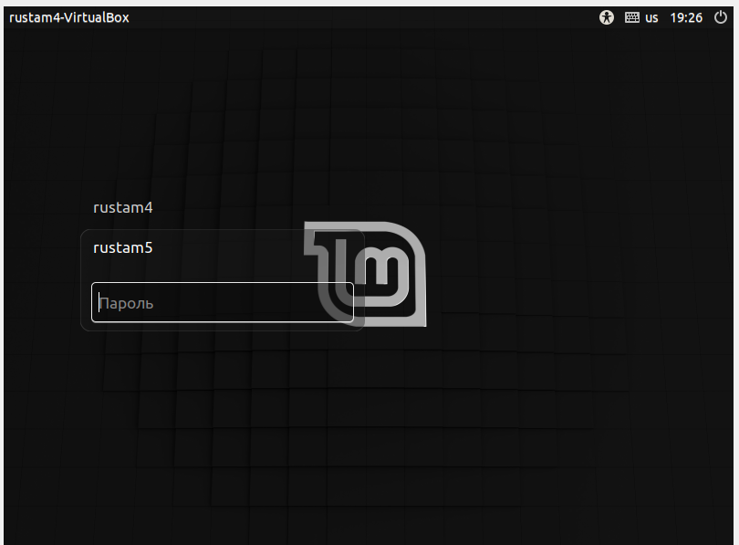

This option doesn’t operate in my VM.

Any way it recommended solution:

<https://access.redhat.com/documentation/en-us/red_hat_enterprise_linux/7/html/system_administrators_guide/sec-terminal_menu_editing_during_boot>

<https://docs.microsoft.com/ru-ru/azure/virtual-machines/linux/serial-console-grub-single-user-mode>

**Option 3**

Adding **init=/sysroot/bin/sh**

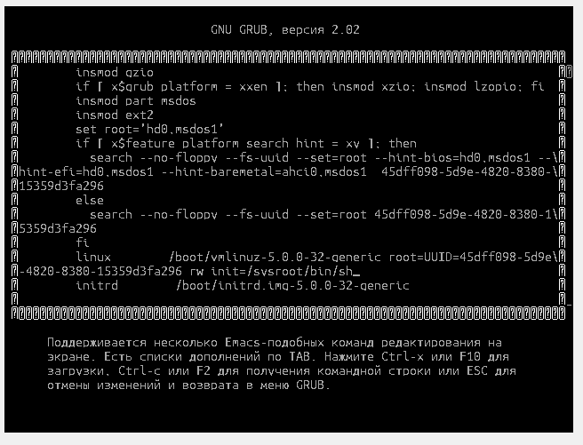

Doesn’t operate correctly in my case